Class Time:
Names:
Hypothesis Testing of Single Mean and Single Proportion: Single Mean and Single Proportion Lab I

Student Learning Outcomes:
- The student will select the appropriate distributions to use in each case.
- The student will conduct hypothesis tests and interpret the results.
Television Survey
In a recent survey, it was stated that Americans watch television on average four hours per day. Assume that σ = 2. Using your class as the sample, conduct a hypothesis test to determine if the average for students at your school is lower.
- Ho: ____________

- Ha: ____________

- In words, define the random variable.

- The distribution to use for the test is

- Determine the test statistic using your data.

- Draw a graph and label it appropriately. Shade the actual level of significance (p-value).
  - Graph: 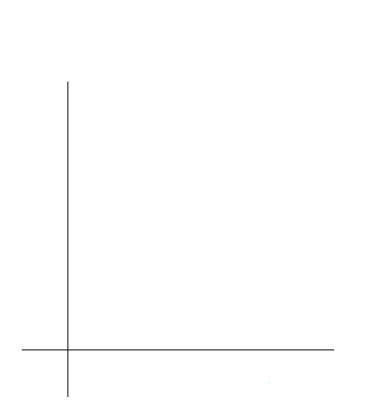
  - Determine the p-value.

- Do you reject or not reject the null hypothesis?

- Write a clear conclusion using a complete sentence.

Language Survey
According to the 2000 Census, about 39.5% of Californians and 17.9% of all Americans speak a language other than English at home. Using your class as the sample, conduct a hypothesis test to determine if the percent of students at your school that speak a language other than English at home is different from 39.5%. (Use 17.9% if this you are surveying outside of California.)
- Ho: ____________

- Ha: ____________

- In words, define the random variable.

- The distribution to use for the test is

- Determine the test statistic using your data.

- Draw a graph and label it appropriately. Shade the actual level of significance.
  - Graph:
  - Determine the p-value.

- Do you reject or not reject the null hypothesis?

- Write a clear conclusion using a complete sentence.

Jeans Survey
Suppose that young adults own an average of 3 pairs of jeans. Survey 8 people from your class to determine if the average is higher than 3.
- Ho: ____________

- Ha: ____________

- In words, define the random variable.

- The distribution to use for the test is

- Determine the test statistic using your data.

- Draw a graph and label it appropriately. Shade the actual level of significance.
  - Graph:
  - Determine the p-value.

- Do you reject or not reject the null hypothesis?

- Write a clear conclusion using a complete sentence.

